

**PROGRAMME TITLE: EBRD UNCITRAL Public Procurement Reform Initiative**

**PROJECT TITLE: Moldova: Assistance with Piloting Electronic Framework Agreements on MTender**

***Deliverable 2*** ***Blueprint for execution of Framework Agreements Workplan ID: P4-T2-A1-M2***

***November 2020***

**APPROVAL PAGE**

November 2020

This document for “Blueprint for execution of FA” of the project “Moldova: Policy advice, legislative drafting and on-going support to the MTender Pilot in 2020” was first prepared as a draft and submitted on the 13th November 2020 by the Consultant: everis and uStudio. It has gone through a number of iterations, and this version 1.0 is the final version. The document has been examined by the EBRD OL and the representatives of the Government Client/Beneficiaries of Republic of Moldova and is hereby recommended for approval and acceptance.

|  |  |
| --- | --- |
| **Client/beneficiary Name** | **Ministry of Finance of the Republic of Moldova** |
| **Project title** | **Moldova: Policy advice, legislative drafting and on-going support to the MTender Pilot in 2020** |
| **Date of scheduled delivery** | 13/11/2020 |
| **Date of submission for acceptance** | 13/11/2020 |

|  |  |  |
| --- | --- | --- |
| **The output is specified in the table below and includes a list of delivered deliverables. The output is in accordance with approved specifications and complies with all conditions defined in the Contract, as per the Terms of Reference.** | | |
| **Deliverable** | **Deliverable Description** | **Acceptance Date** |
| 2 | *P4-T2-A1-M2 Blueprint for execution of FA* |  |
| **All deliverables were prepared in required quality and time and are accepted without open points.**  **Other comments [….]** | | |

|  |  |  |
| --- | --- | --- |
| **Consultancy & Report Author** | Signature: | Date: |
| **Everis Spain, SLU** |
| **Persons authorised to Sign-off** | Signature: | Date: |
| **Eliza Niewiadomska, EBRD OL** |

*Please be advised that the report has been prepared exclusively for EBRD. EBRD makes no representation or warranty, express or implied, as to the accuracy or completeness of the information set forth in this report. EBRD has not independently verified any of the information contained in the report and EBRD accepts no liability whatsoever for any of the information contained in the report or for any misstatement or omission therein. The report remains EBRD’s property*

**DOCUMENT CHARACTERISTICS**

|  |  |
| --- | --- |
| **Property** | **Value Proposition** |
| Release date | *13/11/2020* |
| Status: | *For approval* |
| Version: | *1.0* |
| Authors: | *uStudio, everis* |
| Reviewed by: |  |
| Approved by: |  |

**DOCUMENT HISTORY**

|  |  |  |
| --- | --- | --- |
| **Version** | **Description** | **Date** |
| 1.0 | *First version of the document*  [*https://my.huddle.net/workspace/33889435/files/#/84088834*](https://my.huddle.net/workspace/33889435/files/#/84088834)  [*https://public.breeze.pm/t/dJUAvoxJaT-DkneA0L2SShTUfIgDq_ztjPRNzxVlZhQclg*](https://public.breeze.pm/t/dJUAvoxJaT-DkneA0L2SShTUfIgDq_ztjPRNzxVlZhQclg) | *25/11/2020* |
| 2.0 |  |  |
| 3.0 |  |  |
| 4.0 |  |  |
| 5.0 |  |  |

Table of Contents

1. Introduction 8

1.1 Aim of the document 8

1.2 Alignment with regulation 9

2. Technical design 9

2.1 BPMN 9

2.2 State-chart diagrams 10

2.2.1 Direct purchase 10

2.2.2 Mini-competition 10

2.3 OCDS dataset 10

2.3.1 Issuing of a Direct purchase under a FA 10

2.3.2 Issuing of a Mini-competition under a FA 11

2.4 OCDS dataflow 12

2.4.1 Direct purchase 12

2.4.1.1 State1 - Tendering (active.tendering) 12

2.4.1.1.1 Purchase request 12

2.4.1.1.2 Response to the purchase request 13

2.4.1.2 State1.1 - Unsuccessful completion of responding period (unsuccessful.lackOfOffers) 14

2.4.1.2.1 Indication of the unsuccessful outcome of procurement initiation 14

2.4.1.3 State8.3 - Unsuccessful completion of tendering 14

2.4.1.4 State3 - Evaluation (active.evaluation) 15

2.4.1.4.1 Initiation of evaluation phase 15

2.4.1.4.2 Consideration 16

2.4.1.4.3 Award decision 17

2.4.1.4.4 Cancellation of the award decision 17

2.4.1.4.5 Confirmation of the award decision 18

2.4.1.4.6 Contract initiation 19

2.4.1.4.7 Contract preparation and activation 19

2.4.1.5 State3.1 - Unsuccessful completion of evaluation (unsuccessful.lackOfOffers) 19

2.4.1.5.1 Completion of the evaluation phase 19

2.4.1.5.2 Indication of the unsuccessful outcome of procurement initiation 20

2.4.1.6 State4 - Completion of procedure 21

2.4.1.6.1 Indication of the successful outcome of procurement initiation 21

2.4.2 Mini-competition 21

2.4.2.1 State1 - Tendering (active.tendering) 21

2.4.2.1.1 Call for proposals 21

2.4.2.1.2 Tendering 22

2.4.2.2 State1.1 - Unsuccessful completion of tendering (unsuccessful.lackOfOffers) 23

2.4.2.2.1 Indication of the unsuccessful outcome of procurement 23

2.4.2.3 State 2 - Auction (active.auction) 24

2.4.2.4 State3 - Evaluation (active.evaluation) 24

2.4.2.4.1 Initiation of evaluation phase 24

2.4.2.4.2 Initial ranking on award criteria 25

2.4.2.4.3 Consideration 26

2.4.2.4.4 Award decision 27

2.4.2.4.5 Cancellation of the award decision 28

2.4.2.4.6 Confirmation of the award decision 28

2.4.2.4.7 Contract initiation 29

2.4.2.4.8 Contract preparation and activation 29

2.4.2.5 State3.2 - Unsuccessful completion of evaluation (unsuccessful.lackOfOffers) 29

2.4.2.5.1 Completion of the evaluation phase 30

2.4.2.5.2 Indication of the unsuccessful outcome of procurement initiation 30

2.4.2.6 State4 - Completion of procedure 31

2.4.2.6.1 Indication of the successful outcome of procurement initiation 31

**LIST OF FIGURES**

Figure 1 – BPMN for the execution of a FA 9

Figure 2 – State-chart diagram for direct purchase under a FA 10

Figure 3 – State-chart diagram for mini-competition under a FA 10

Figure 4 – Code for issuing of a Direct purchase under a FA 11

Figure 5 – Code for issuing a Mini-competition under a FA 12

Figure 6 – Code for establishing the period of a Purchase request 12

Figure 7 – Code for information of a bid 13

Figure 8 – Code for unsuccessful outcome of procurement initiation at lot level 14

Figure 9 – Code for unsuccessful outcome of procurement initiation at tender level 14

Figure 10 – Code for quotation information 15

Figure 11 – Code for period for evaluation 15

Figure 12 – Code for evaluation of envelopes 16

Figure 13 – Code for award details 17

Figure 14 – Code for award decision 17

Figure 15 – Code for cancellation of the award decision 18

Figure 16 – Code negative award decision 18

Figure 17 – Code for positive award decision 18

Figure 18 – Code for contract initiation 19

Figure 19 –Code for closure of the evaluation phase 20

Figure 20 – Code for unsuccessful lot 20

Figure 21 – Code for unsuccessful procurement initiation 20

Figure 22 – Code for successful lot 21

Figure 23 – Code for successful procurement initiation 21

Figure 24 – Code for establishing the period for Call for proposals 22

Figure 25 – Code for bid information 23

Figure 26 – Code for unsuccessful lot 23

Figure 27 – Code for unsuccessful purchase request 23

Figure 28 – Code for tender information 24

Figure 29 – Code for evaluation period 25

Figure 30 – Code for evaluation of envelopes 25

Figure 31 – Code for award information 27

Figure 32 – Code for award decision 28

Figure 33 – Code for cancellation of award decision 28

Figure 34 – Code for confirmation of award decision 28

Figure 35 – Code for positive award decision 29

Figure 36 – Code for contract initiation 29

Figure 37 – Code for closure of the evaluation phase 30

Figure 38 – Code for unsuccessful outcome of procurement initiation at lot level 30

Figure 39 – Code for unsuccessful outcome of procurement initiation at tender level 30

Figure 40 – Code for successful outcome of procurement initiation at lot level 31

Figure 41 – Code for successful outcome of procurement initiation at tender level 31

**ABBREVIATIONS**

|  |  |
| --- | --- |
| **Term** | **Description** |
| BPMN | Business Process Model Notation |
| CA | Contracting Authority |
| CN | Contract Notice |
| CPB | Central Purchasing Body |
| EBRD | European Bank for Reconstruction and Development |
| EO | Economic Operator |
| FA | Framework Agreement |
| MC | Mini Competition |
| NEPP | Networking Electronic Procurement Platform |
| OCDS | Open Contracting Data Standard |
| PC | Purchase Contract |
| PR | Purchase Request |

**GLOSSARY:**

|  |  |
| --- | --- |
| **Term** | **Description** |
| MTender | MTender is an end-to-end eProcurement system implemented in Moldova that aims at covering the full public procurement cycle. It is based on a multi‑platform networking digital procurement model, comprising a government‑operated web portal and the Open Data central database unit, which is networking with several commercial electronic platforms certified to support electronic tendering procedures for public sector and commercial clients. |

# Introduction

In the context of a transition to digital public procurement in the Republic of Moldova, a new electronic procurement system was developed and implemented with the European Bank for Reconstruction and Development (EBRD) support.

Phase 4 of the project is focused on electronic Framework Agreement (FA), covering both the conclusion of the FA and the subsequent purchases under a FA using the different types of contracts based on a FA (direct purchase, second-stage competition, etc.), and enabling the participation of Central Purchasing Bodies (CPB) with a specific role in the process.

The use of FA will:

* improve value for money and achieve cost savings by aggregating demand and getting better value for money through economies of scale;
* reduce the administrative burden by lowering the number of procedures a Contracting Authority (CA) has to run and, therefore, decreasing the time and costs linked to carrying out procurement. The diminished administrative burden also applies to Economic Operators (EO) that are either awarded a contract directly or are invited to participate in a simplified “Mini Competition” (MC) within the FA;
* enable CAs to effectively manage procurement when they cannot objectively foresee the exact type and/or amount of supplies, services and works for a forthcoming period.

## Aim of the document

The main purpose of this document is to provide a detailed technical design in order for the Networking Electronic Procurement Platforms (NEPPs) to be able to implement all the necessary processes and functionalities related to the execution of FAs in their platforms.

When a FA has been concluded with more than one EO, that FA shall be performed in one of the following ways by the CA or the CPB:

* Following the terms and conditions of the FA, without the reopening competition, by awarding a contract directly to a specific EO applying the terms governing the provision of the works, services and supplies concerned and the objective conditions set in the FA;
* Where not all the terms governing the provision of the works, services and supplies are laid down in the FA, through reopening competition amongst the EOs parties to the FA;
* Partly without reopening of competition and partly with reopening of competition amongst the EOs parties to the FA, where this possibility has been stipulated in the procurement documents for the FA.

Conclusion of the FA is described in a separate document[1].

## Alignment with regulation

This blueprint is aligned with the following regulation:

* Regulation on procurements conducted through framework agreements[2]

# Technical design



## BPMN

The diagram below shows the general processes for the execution of a FA with the different types of contracts based on a FA:

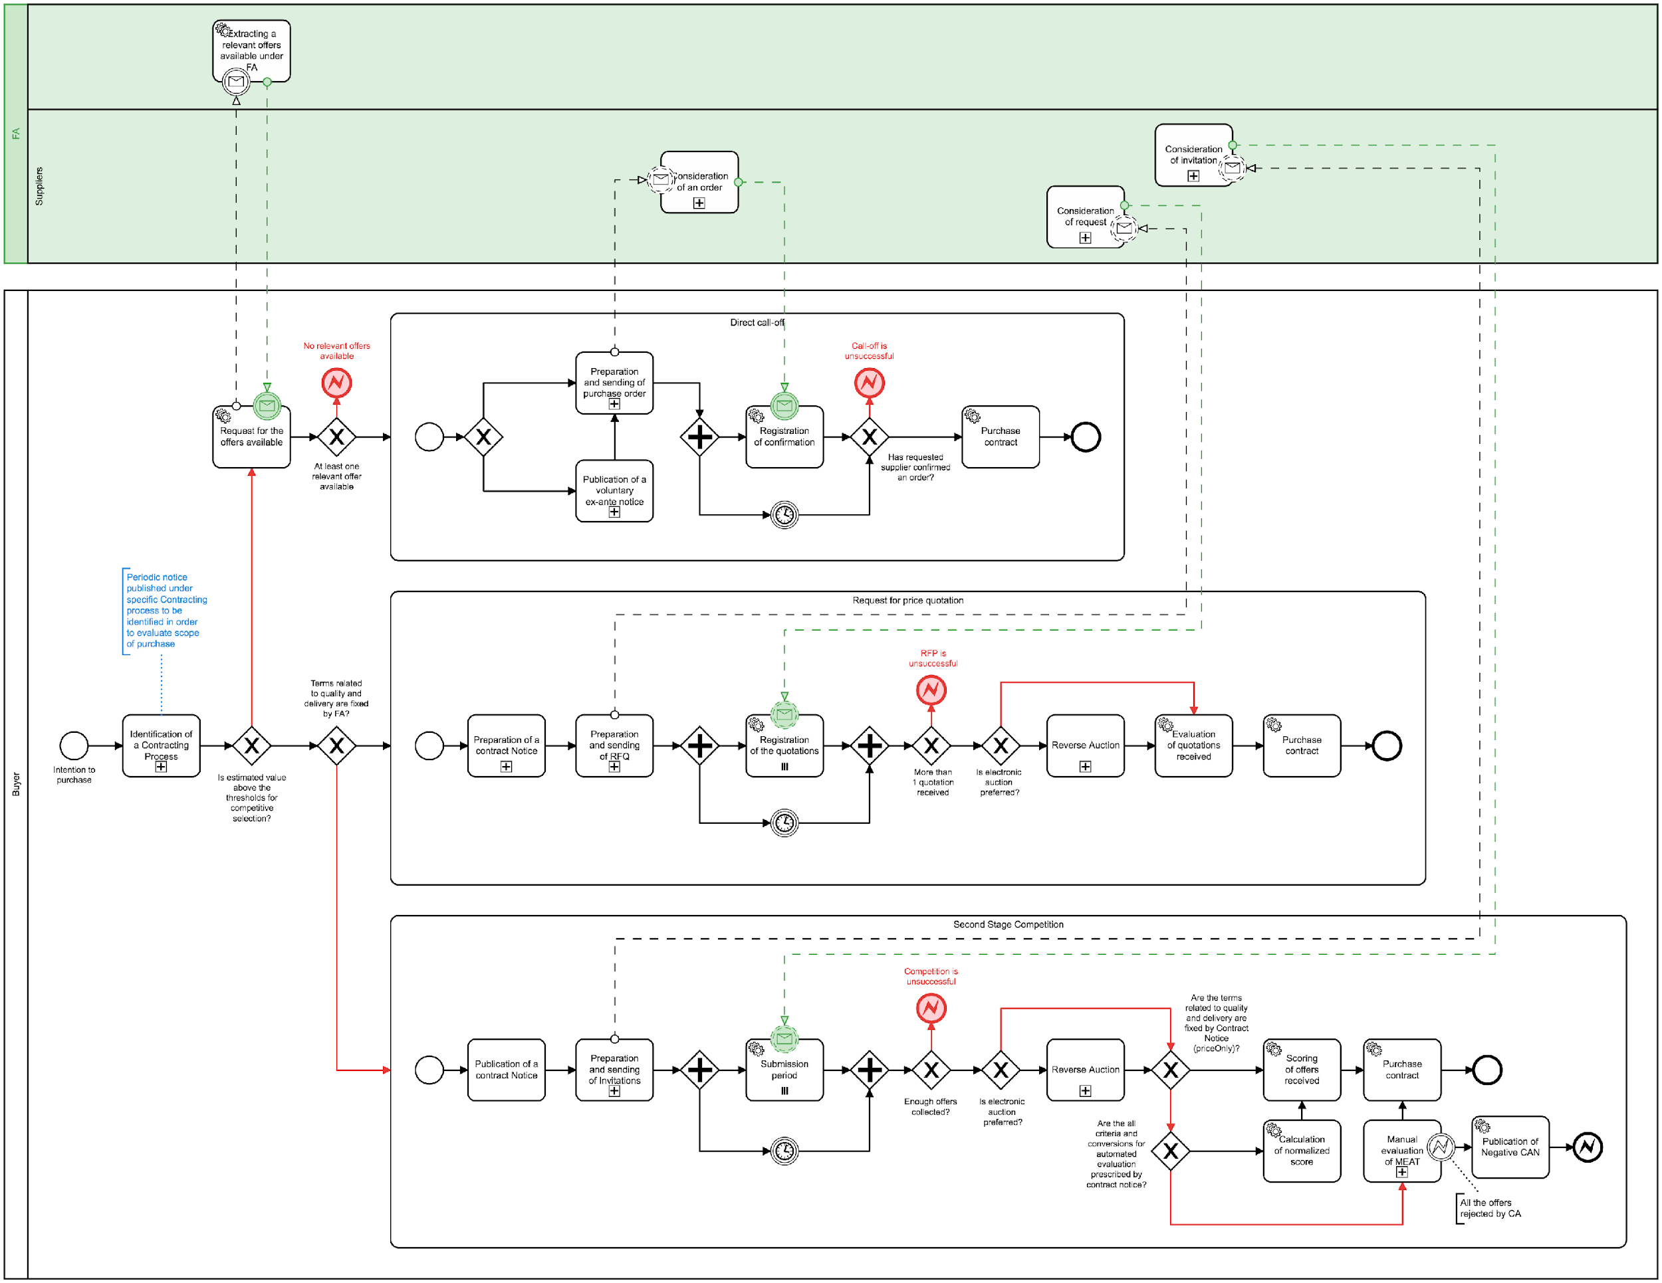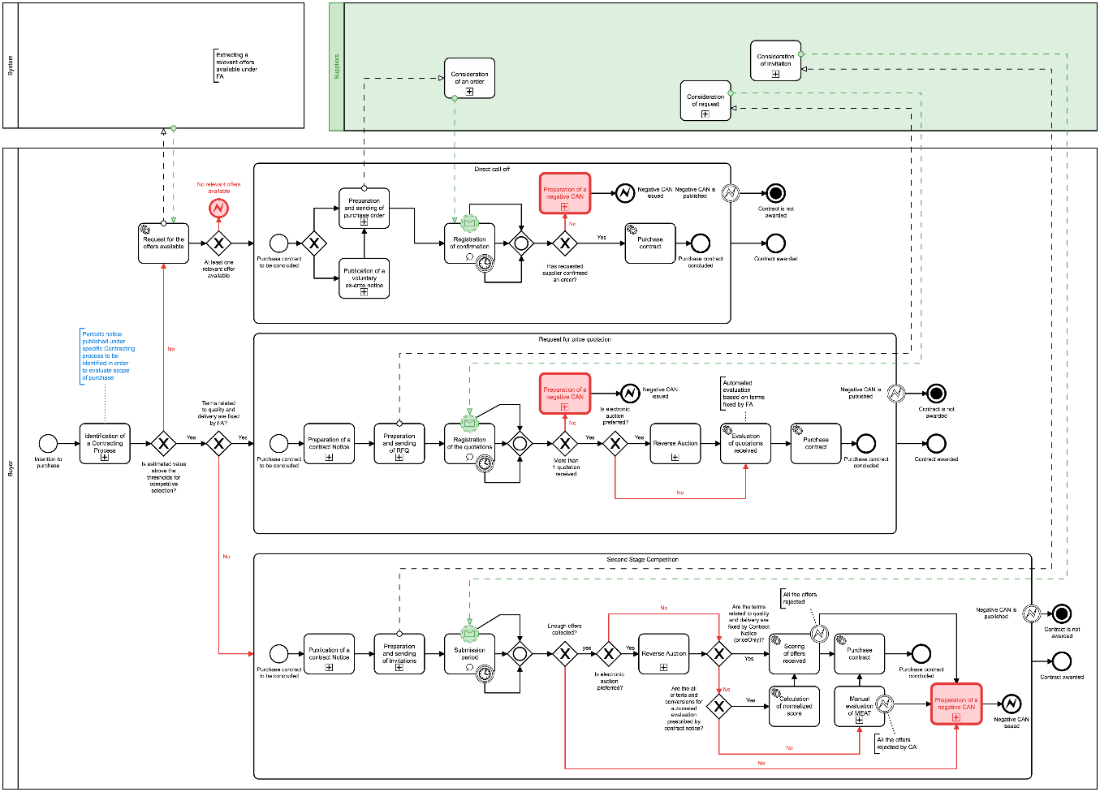

Figure 1 – BPMN for the execution of a FA[3]

## State-chart diagrams

## Direct purchase

The following diagram presents the sequence of stages applicable for the execution of a FA based on direct purchase following the terms and conditions of the FA, without reopening competition, by awarding a contract directly to a specific EO applying the terms governing the provision of the works, services and supplies concerned and the objective conditions set in the FA:

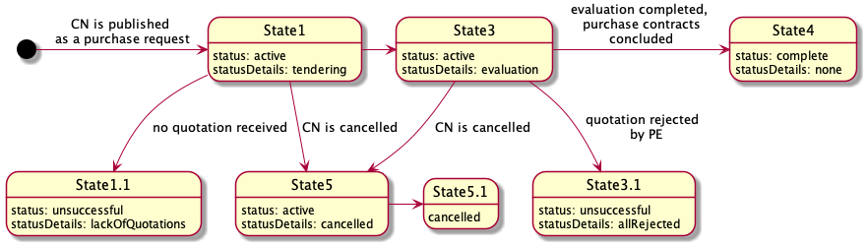

Figure 2 – State-chart diagram for direct purchase under a FA

## Mini-competition

The following diagram presents the sequence of stages applicable for the execution of a FA based on reopening of competition (partially or completely) amongst the EOs parties to the FA:

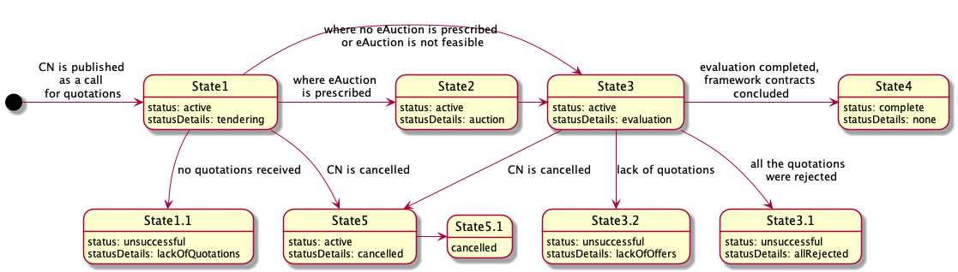

Figure 3 – State-chart diagram for mini-competition under a FA

Further detail on the different statuses is provided in section “2.4 OCDS dataflow” of this document.

## OCDS dataset

## Issuing of a Direct purchase under a FA

This request shall be formed on the basis of the FA execution and include:

* Products category determined for this request;
* precise technical specification;
* lots (where applicable);
* specific nomenclature;
* terms and conditions which are non-fixed in the (if any);
* evaluation criteria.

|  |
| --- |
| {  "tender": {  "id": "",  "classification": {},  "status": "",  "targets": "",  "criteria": [],  "conversions": [],  "awardCriteria": "",  "awardCriteriaDetails": "",  "lots": [],  "items": [  {  "id": "",  "description": "",  "relatedLot": "",  "deliveryAddress": {},  "quantity": "",  "unit": {}  }  ]  }  } |

Figure 4 – Code for issuing of a Direct purchase under a FA

## Issuing of a Mini-competition under a FA

This request shall be formed on the basis of the FA execution and include:

* products category determined for this request;
* minimum technical specification (where applicable);
* lots (where applicable);
* specific nomenclature;
* terms and conditions which are non-fixed in the FA (if any);
* awarding methodology and evaluation criteria and techniques.

|  |
| --- |
| {  "tender": {  "id": "",  "classification": {},  "status": "",  "targets": "",  "criteria": [],  "conversions": [],  "awardCriteria": "",  "awardCriteriaDetails": "",  "procurementMethodModalities": [],  "lots": [],  "items": [  {  "id": "",  "description": "",  "relatedLot": "",  "deliveryAddress": {},  "quantity": "",  "unit": {}  }  ]  }  } |

Figure 5 – Code for issuing a Mini-competition under a FA

## OCDS dataflow

## Direct purchase

## State1 - Tendering (active.tendering)

Together with the publication of the Purchase Request (PR), the CA shall initiate a period for the response by a quoted party of the FA.

## Purchase request

In order to indicate the initiation of the period for the quoted party of a FA to respond to a PR, the CA shall establish the start and end dates of such period. This shall be done by adding a separate tenderPeriod object into the tender building block, which will reflect the end date of the period for response prescribed by the CA and its start date, reflected as a system moment of initiation of the tendering phase:

|  |
| --- |
| {  "tender": {  "tenderPeriod": {  "startDate": "",  "endDate": ""  }  }  } |

Figure 6 – Code for establishing the period of a Purchase request

## Response to the purchase request

The EO that is party to the FA is the only one allowed to submit a quotation within the given tender.tenderPeriod indicated in a PR:

* Quotation is based on Bids schema.
* Quotation shall fulfil all the requirements prescribed by Criteria related to items or to lots with a relevant list of the responses by the EO, providing an array of requirementResponses.

|  |
| --- |
| *Having a set of requirements predefined by the CA and a number of values available, the EO preparing a submission includes values for each requirement, reflecting the substance of the quotation and fulfilling general corporate profiles’ data, as requested by the CA or required by the legal framework of a particular jurisdiction.* |

Each offer includes:

1. An organization profile according to the extended Organization model (or a reference to such a profile previously sent within the FA);
2. a set of documents of the tender, specified with relevant types of documents for their future splitting into the different "envelopes";
3. absolute financial value of the tender;
4. a set of required responses according to the criteria specified by the CA within the Contract Notice (CN) related to the financial part of the offer:

* reflections on requirements characterise the nature of the subject of procurement;
* reflections on requirements characterise the nature of the delivery and post-delivery.

|  |
| --- |
| {  "bid": {  "id": "",  "status": "",  "relatedLots": [],  "tenderers":[],  "items": [  {  "id": "",  "description": "",  "quantity": "",  "unit": {},  "relatedLot":""  }  ],  "requirementResponses":[]  }  } |

Figure 7 – Code for information of a bid

The quotation received remains confidential and closed until expiration of the period for tendering (tender.tenderPeriod.endDate).

## State1.1 - Unsuccessful completion of responding period (unsuccessful.lackOfOffers)

When the quoted EO does not respond within the given period, the evaluation phase will end in an unsuccessful way with no future actions by the CA. Procurement initiation shall be moved to a phase of preparation of a negative award notice.

## Indication of the unsuccessful outcome of procurement initiation

When absence of the requested quotation is the case, the relevant unsuccessful character shall be reflected for lots or for the entire PR.

For lots

A negative character of procurement under a specific lot is reflected with lot.status: unsuccessful, where the lot is closed unsuccessfully due to the lack of submission of a tender by the quoted EO, or when the received tender was rejected.

|  |
| --- |
| {    "lots": [      {        "status": "unsuccessful"      }    ]  } |

Figure 8 – Code for unsuccessful outcome of procurement initiation at lot level

For entire initiation (purchase request)

Where all the lots are unsuccessful, the entire procurement initiation goes to State8.3 (described in Section 2.4.1.3 of this document).

A negative character of a procurement under entire initiation (procurement process) is reflected with tender.status: unsuccessful, where the initiation is closed unsuccessfully due to the lack of submission by the quoted EO or where the received tender was rejected. Details of a negative closure are reflected in tender.statusDetails.

|  |
| --- |
| {    "tender": {      "status": "unsuccessful",  "statusDetails": "lackOfOffers"    }  } |

Figure 9 – Code for unsuccessful outcome of procurement initiation at tender level

## State8.3 - Unsuccessful completion of tendering

Where no tender was collected during the tendering period for all the announced lots, the evaluation phase will end unsuccessfully with no future actions by the CA. The procurement process shall be moved to a phase of preparation of a negative award notice.

## State3 - Evaluation (active.evaluation)

Once the tenderPeriod.endDate is achieved, the quotation received under this request shall be fully disclosed and available for the evaluation of the CA.

## Initiation of evaluation phase

For the evaluation of the quotation received, the following technical steps shall be performed on a system level:

Disclosure of quotation

When a quotation is provided by the quoted EO, it is disclosed as a bid according to the relevant schema. An author (bid.tenderers) is updated into parties as an Organization with a role: tenderer.

|  |
| --- |
| {  "bids": {  "details":[  {  "id": "",  "status": "pending",  "statusDetails":""  "relatedLots": [],  "tenderers":[],  "items": [  {  "id": "",  "description": "",  "quantity": "",  "unit": {},  "relatedLot":""  }  ],  "requirementResponses":[]  }  }  ]  } |

Figure 10 – Code for quotation information

Establishment of a period for evaluation

A separate object awardPeriod is added into tender block where the specific start date for awarding is determined automatically. Such block is based on Period schema.

|  |
| --- |
| {  "tender": {  "awardPeriod": {  "startDate": ""  }  }  } |

Figure 11 – Code for period for evaluation

Evaluation envelopes

Along with the establishment of the tender.awardPeriod.startDate, the evaluation envelope – award is generated for the quotation received. This object is based on the Awards schema and is initially established with status:pending.

|  |
| --- |
| {  "awards": [  {  "id": "",  "status": "pending",  "suppliers": [],  "relatedLots": [],  "relatedBid": ""  }  ]  } |

Figure 12 – Code for evaluation of envelopes

## Consideration

Evaluation

In order to evaluate the award, the CA shall update it with all the required meta-data:

* add any documents, if needed;
* add requirementResponses if there are relevant requirements related to the CA within the evaluation phase prescribed by tender.criteria;
* add text descriptions where any justification is needed;
* add date when the decision was taken;
* add internalID, if any.

Indication of a decision

Once the evaluation of the specific bid is complete and the related award is fully updated with all relevant data, the CA shall switch the award to one of the following states, reflecting a positive or negative decision:

* award.statusDetails: active - means the related bid is selected as the winning tender to be awarded;
* award.statusDetails: unsuccessful - means the related bid is rejected.

|  |
| --- |
| {  "awards": [  {  "id": "",  "description": "",  "status": "pending",  "date": "",  "suppliers": [],  "relatedLots": [],  "bidId": "",  "documents": [],  "requirementResponses": [],  "indernalId": ""  }  ]  } |

Figure 13 – Code for award details

As soon as the CA has completed the evaluation, the CA indicates the end of the evaluation by publishing an intention to award a contract (award decision).

## Award decision

To reflect a decision regarding a Purchase Contract (PC), the CA prepares a Notice on Award Decision. This data-entity is based on Contract schema and is included in contracts array.

Initially, this contract is established with status: pending and a statusDetails which reflects a decisions' character:

* statusDetails: active - the decision regarding quotation is positive (winner is identified);
* statusDetails: unsuccessful - the decision regarding quotation is negative (the quotation was rejected).

|  |
| --- |
| {    "contracts": [      {        "id": "",  "date": "",  "awardId": "",  "status": "pending",  "statusDetails": "active",      }    ]  } |

Figure 14 – Code for award decision

## Cancellation of the award decision

To reflect the decision to cancel a specific award, taken previously for a particular quotation, the CA shall switch relevant contract object into contract.status: cancelled.

|  |
| --- |
| {    "contracts": [      {        "status": "cancelled"      }    ]  } |

Figure 15 – Code for cancellation of the award decision

## Confirmation of the award decision

If no blockers are indicated, the CA can initiate the contract preparation for the awarded quotation or the finalization of an unsuccessful output of a PR where the received quotation was rejected during the evaluation phase.

Confirmation of a negative award decision

Confirmation of a negative award decision requires to switch the relevant contract object into final status unsuccessful, with parallel indication of the reason for a negative outcome in statusDetails.

|  |
| --- |
| {  "contracts" : [  {  "id":"",  "awardId":"",  "status":"unsuccessful",  "statusDetails": "allOffersRejected"  }  ]  } |

Figure 16 – Code negative award decision

Confirmation of a positive award decision

Confirmation of a positive decision requires reflecting the subsequent contract initiation into a relevant contract object by indicating statusDetails, provided that the object remains in an intermediate status: pending.

|  |
| --- |
| {  "contracts" : [  {  "id":"",  "awardId":"",  "status":"pending",  "statusDetails": "contractPreparation"  }  ]  } |

Figure 17 – Code for positive award decision

## Contract initiation

To describe and reflect the scope of a PC to be concluded on a positive award decision, a parallel data-stream will be initiated. This stream is a separate OCDS-record where all the information related to the future contract is collected from the current procurement process. In order to establish the relation with this parallel stream, the relevant contract reflects the positive award decision and shall be extended with relatedProcess.relationship: [x_contracting].

|  |
| --- |
| {  "contracts" : [  {  "id":"",  "awardId":"",  "status":"pending",  "statusDetails": "contractPreparation",  "relatedProcesses": [  {  "id": "",  "relationship": [  "x_contracting"  ],  "scheme": "ocid"  }  ]  }  ]  } |

Figure 18 – Code for contract initiation

## Contract preparation and activation

According to the common flow of MTender, the preparation of a contract is concluded.

## State3.1 - Unsuccessful completion of evaluation (unsuccessful.lackOfOffers)

If the received quotation was rejected, the evaluation phase will end in an unsuccessful way with no future actions by the CA.

## Completion of the evaluation phase

The previously opened period for evaluation shall be closed by adding a separate endDate attribute for awardPeriod.

|  |
| --- |
| {  "tender": {  "awardPeriod": {  "endDate": ""  }  }  } |

Figure 19 –Code for closure of the evaluation phase

## Indication of the unsuccessful outcome of procurement initiation

When the quotation received is rejected, the unsuccessful result shall be reflected for lots or for the entire PR.

For lots

A negative character under a specific lot is reflected with lot.status: unsuccessful, where the lot is closed in a negative way due to the lack of submission of quotation or where the received quotation was rejected.

|  |
| --- |
| {    "lots": [      {        "status": "unsuccessful"      }    ]  } |

Figure 20 – Code for unsuccessful lot

For entire initiation (tender)

A negative character under the entire initiation (procurement process) is reflected with tender.status: unsuccessful, where the initiation is closed in a negative way due to the lack of submission of quotation or where the received quotation was rejected. The details of a negative closure are reflected in tender.statusDetails.

|  |
| --- |
| {    "tender": {      "status": "unsuccessful",  "statusDetails": ""    }  } |

Figure 21 – Code for unsuccessful procurement initiation

## State4 - Completion of procedure

## Indication of the successful outcome of procurement initiation

When the PC was concluded under a relevant request, a positive character of a process shall be reflected for both the lot and the entire PR:

For lots

A positive character under a specific lot is reflected with lot.status: complete.

|  |
| --- |
| {    "lots": [      {      "status": "complete"      }    ]  } |

Figure 22 – Code for successful lot

For entire process

A positive character under an entire initiation (procurement process) is reflected with tender.status: complete.

|  |
| --- |
| {    "tender": {      "status": "complete"    }  } |

Figure 23 – Code for successful procurement initiation

## Mini-competition

## State1 - Tendering (active.tendering)

Together with the publication of the PR, the CA shall initiate a period for submission of quotations by the EOs that are party of the FA.

## Call for proposals

In order to indicate the start of the tendering phase of a procurement process, the CA shall establish a start date as a call for tendering of the commercial tenders. This indication shall be done by adding a separate tenderPeriod object into the tender building block, which will reflect an end date of the tendering phase prescribed by the CA, and its start date is reflected as a system moment of initiation of the tendering phase:

|  |
| --- |
| {  "tender": {  "tenderPeriod": {  "startDate": "",  "endDate": ""  }  }  } |

Figure 24 – Code for establishing the period for Call for proposals

## Tendering

Each invited EO (party to the FA) is allowed to submit a tender - quotation within the given tender.tenderPeriod indicated in the PR.

* Each quotation is based on Bids schema.
* Each quotation shall fulfil all the requirements prescribed by Criteria related to items or lots with a relevant list of the responses by the EO, providing an array of requirementResponses.

|  |
| --- |
| Having a set of requirements predefined by the CA and a number of values available, EOs preparing a submission include values for each requirement, reflecting the substance of the submission and fulfilling general corporate profiles’ data, as requested by the CA or required by the Legal Framework of a particular jurisdiction. |

Each tender includes:

1. An organization profile according to the extended Organization model (or a reference on such a profile previously sent within the FA);
2. a set of documents of the tender, specified with relevant types of documents for their future splitting into the different "envelopes";
3. absolute financial value of the tender;
4. a set of required responses according to the criteria specified by the CA within the PR:

* reflections on requirements characterise the nature of the subject of procurement;
* reflections on requirements characterise the nature of the delivery and post-delivery.

|  |
| --- |
| {  "bid": {  "id": "",  "status": "",  "relatedLots": [],  "tenderers":[],  "items": [  {  "id": "",  "description": "",  "quantity": "",  "unit": {},  "relatedLot":""  }  ],  "requirementResponses":[]  }  } |

Figure 25 – Code for bid information

All the tenders collected remain confidential and closed until the expiration of the period for tendering (tender.tenderPeriod.endDate). Once the tender.tenderPeriod.endDate is achieved, no tenders can be received, withdrawn or corrected.

## State1.1 - Unsuccessful completion of tendering (unsuccessful.lackOfOffers)

Where not enough tenders were collected during the tendering period for all the announced lots, the evaluation phase will end unsuccessfully with no future actions by the CA. The procurement process shall be moved to a phase of preparation of a negative award notice.

## Indication of the unsuccessful outcome of procurement

When absence of tenders is the case, the relevant unsuccessful character shall be reflected for lots or for the entire PR.

For lots

A negative character under a specific lot is reflected with lot.status: unsuccessful, where the lot is closed unsuccessfully due to the lack of submission of tenders by the EOs party to the FA, or when the received tenders were rejected.

|  |
| --- |
| {    "lots": [      {        "status": "unsuccessful"      }    ]  } |

Figure 26 – Code for unsuccessful lot

For entire initiation (purchase request)

When all the lots are unsuccessful, the entire procurement initiation goes to State8.3 (described in Section 2.4.1.3 of this document).

A negative character under the entire initiation (procurement process) is reflected with tender.status: unsuccessful, where the initiation is closed unsuccessfully due to the lack of submission of tenders by the EOs party to the FA, or when the received tenders were rejected. Details of a negative closure are reflected in tender.statusDetails.

|  |
| --- |
| {    "tender": {      "status": "unsuccessful",  "statusDetails": "lackOfOffers"    }  } |

Figure 27 – Code for unsuccessful purchase request

## State 2 - Auction (active.auction)

Where electronic auction as a technique for the awarding of the contract was prescribed in the PR, all the tenders received shall be partially disclosed in order to establish an auction.

## State3 - Evaluation (active.evaluation)

Once the tenderPeriod.endDate is achieved (when electronic auction was not prescribed in the PR) or when the electronic auction is completed, all tenders received under this request shall be fully disclosed and available for the evaluation of the CA.

## Initiation of evaluation phase

For the evaluation of the tenders received, the following technical steps shall be performed on a system level.

Disclosure of tenders

Tenders are disclosed in a bids array. Authors (bid.tenderers) are updated into parties as an Organization with a role: tenderer.

|  |
| --- |
| {  "bids": {  "details":[  {  "id": "",  "status": "pending",  "statusDetails":""  "relatedLots": [],  "tenderers":[],  "items": [  {  "id": "",  "description": "",  "quantity": "",  "unit": {},  "relatedLot":""  }  ],  "requirementResponses":[]  }  }  ]  } |

Figure 28 – Code for tender information

Establishment of a period for evaluation

A separate object awardPeriod is added into tender block where the specific start date for awarding is determined automatically. Such block is based on a Period schema.

|  |
| --- |
| {  "tender": {  "awardPeriod": {  "startDate": ""  }  }  } |

Figure 29 – Code for evaluation period

Evaluation envelopes

Along with the establishment of the tender.awardPeriod.startDate, an evaluation envelope – award is generated for each tender received. These objects are based on the Awards schema and are initially established with status:pending.

|  |
| --- |
| {  "awards": [  {  "id": "",  "status": "pending",  "suppliers": [],  "relatedLots": [],  "relatedBid": ""  }  ]  } |

Figure 30 – Code for evaluation of envelopes

Disclosure of enquirers

Together with the initiation of the evaluation phase, all enquirers (tender.enquiries[*].author) are reflected into parties array according to Organization block schema with role: enquirer.

## Initial ranking on award criteria

Depending on tender.awardCriteria and tenderAwardCriteriaDetails, an initial automated ranking can or cannot be done:

|  |  |  |  |  |
| --- | --- | --- | --- | --- |
| **awardCriteriaDetatils / awardCriteria** | **priceOnly** | **costOnly** | **qualityOnly** | **ratedCriteria** |
| automated | bid.value | bid.requirementResponses * lot.value | bid.requirementResponses * 1 | bid.requirementResponses * bid.value |
| manual |  |  |  |  |

Table – Automated and manual award criteria depending on the ranking approach

As shown in the table, automated ranking can be undertaken automatically using a set of criteria and the relevant conversions applied by the CA for each available value of each applied requirement published in a CN, on one hand; and the bid.requirementResponses submitted by each EO party to the FA against published criteria on the other hand. These two data-sets allow the normalised value for each bid based on the same approach to be calculated.

Normalised price

Where normalised price must be calculated, the following formula is applied for each tender in order to identify which one is most suitable by normalised price:

*Pn = P * C1 * C2 * ... Cn*

where:

* Pn - value of normalised price
* P - basic price taken from bid.value or lot.value or equal to '1' depending on awardCriteria
* C1 ... Cn - values of the coefficients to be applied (related with values of requirements, available for supplier and indicated in requirementResponses)

Ranking approach

* priceOnly

Where awardCriteria: priceOnly - only bid.value is compared in order to identify the most suitable tender. Cheapest goes first.

* costOnly

Where awardCriteria: costOnly – the assumption is that all the tenderers have the same bid.value equal to lot.value. It means that the normalised price needs to be calculated for each bid received based on lot.value as a basis. Cheapest goes first.

* qualityOnly

Where awardCriteria: qualityOnly – the assumption is that the price doesn't matter and the only valuable part of the tender is quality - meaning set of values of criteria, selected by the EO while submitting a bid. It means that the normalised price needs to be calculated for each bid received, based on '1'. Most qualified goes first.

* ratedCriteria

Where awardCriteria: ratedCriteria – the assumption is that both price and value matter. It means that the normalised price needs to be calculated for each bid received based on ‘bid.value'. Cheapest goes first.

Where automated ranking is the case, all the awards are ranked into order for evaluation and the first award (most suitable according to the prescribed evaluation function) will be switched to the next state ‘available for evaluation’ by the CA.

## Consideration

Evaluation

In order to evaluate an award, the CA shall update it with all the required meta-data:

* Add any documents, if needed;
* add requirementResponses if there are relevant requirements related to the CA within the evaluation phase prescribed by tender.criteria;
* add text descriptions where any justification is needed;
* add date when the decision was taken;
* add internalID, if any.

Indication of a decision

Once the evaluation of a specific bid is complete and the related award is fully updated with all relevant data, the CA shall switch the award to one of the following states, reflecting a positive or negative decision:

* award.statusDetails: active - means the related bid is selected as a winning tender to be awarded;
* award.statusDetails: unsuccessful - means the related bid is rejected.

|  |
| --- |
| {  "awards": [  {  "id": "",  "description": "",  "status": "pending",  "date": "",  "suppliers": [],  "relatedLots": [],  "bidId": "",  "documents": [],  "requirementResponses": [],  "indernalId": ""  }  ]  } |

Figure 31 – Code for award information

As soon as the CA has completed the evaluation and the winning tender for each lot is identified or all the tenders for this lot are rejected, the CA indicates the end of the evaluation for the lot by publishing an intention to award a PC (award decision).

## Award decision

To reflect the decision regarding each lot and the tender selected to be awarded a PC (award.statusDetails:active), the CA prepares a Notice on Award Decision. This data-entity is based on Contract schema and included in contracts array.

Initially, this contract is established with status: pending and statusDetails which reflect a decisions' character:

* statusDetails: active where the decision regarding the lot is positive (winner is identified);
* statusDetails: unsuccessful where the decision regarding the lot is negative (all tenders were rejected).

|  |
| --- |
| {    "contracts": [      {        "id": "",  "date": "",  "awardId": "",  "status": "pending",  "statusDetails": "contractProject",      }    ]  } |

Figure 32 – Code for award decision

## Cancellation of the award decision

To reflect a decision to cancel a specific award decision taken previously for a particular lot, the CA shall switch relevant contract object into contract.status: cancelled.

|  |
| --- |
| {    "contracts": [      {        "status": "cancelled"      }    ]  } |

Figure 33 – Code for cancellation of award decision

## Confirmation of the award decision

If no blockers are indicated, the CA can initiate the contract preparation for the awarded lot or the finalization of an unsuccessful output of the lot.

Confirmation of a negative award decision

Confirmation of negative award decision requires to switch the relevant contract object into final status unsuccessful, with a parallel indication of the reason for a negative outcome as statusDetails.

|  |
| --- |
| {  "contracts" : [  {  "id":"",  "awardId":"",  "status":"unsuccessful",  "statusDetails": "allOffersRejected"  }  ]  } |

Figure 34 – Code for confirmation of award decision

Confirmation of a positive award decision

Confirmation of a positive decision requires reflecting the subsequent contract initiation into a relevant contract object by indicating statusDetails, provided that the object remains in an intermediate status: pending.

|  |
| --- |
| {  "contracts" : [  {  "id":"",  "awardId":"",  "status":"pending",  "statusDetails": "contractPreparation"  }  ]  } |

Figure 35 – Code for positive award decision

## Contract initiation

To describe and reflect the scope of a PC to be concluded on a positive award decision, a parallel data-stream will be initiated. This stream is a separate OCDS-record where all the information related to the future PC is collected from the current procurement process.

In order to establish the relation with this parallel stream, the relevant contract reflects the positive award decision and shall be extended with relatedProcess.relationship: [x_contracting]

|  |
| --- |
| {  "contracts" : [  {  "id":"",  "awardId":"",  "status":"pending",  "statusDetails": "contractPreparation",  "relatedProcesses": [  {  "id": "",  "relationship": [  "x_contracting"  ],  "scheme": "ocid"  }  ]  }  ]  } |

Figure 36 – Code for contract initiation

## Contract preparation and activation

According to the common flow of MTender, the preparation of a contract is concluded.

## State3.2 - Unsuccessful completion of evaluation (unsuccessful.lackOfOffers)

When all the tenders collected during the period of tendering were rejected, the evaluation phase will end unsuccessfully with no future actions by the CA,

## Completion of the evaluation phase

The previously opened period for evaluation shall be closed by adding a separate endDate attribute for awardPeriod:

|  |
| --- |
| {  "tender": {  "awardPeriod": {  "endDate": ""  }  }  } |

Figure 37 – Code for closure of the evaluation phase

## Indication of the unsuccessful outcome of procurement initiation

Where all received tenders are rejected, the unsuccessful character shall be reflected for lots or for the entire PR.

For lots

A negative character under a specific lot is reflected with lot.status: unsuccessful, where the lot is closed in a negative way due to the lack of submission of tenders or where all the received tenders were rejected.

|  |
| --- |
| {    "lots": [      {        "status": "unsuccessful"      }    ]  } |

Figure 38 – Code for unsuccessful outcome of procurement initiation at lot level

For entire initiation (tender)

A negative character under the entire initiation (procurement process) is reflected with tender.status: unsuccessful, where the initiation is closed in a negative way due to the lack of submission of tenders or where all the received tenders were rejected. The details of a negative closure are reflected in tender.statusDetails.

|  |
| --- |
| {    "tender": {      "status": "unsuccessful",  "statusDetails": "allRejected"    }  } |

Figure 39 – Code for unsuccessful outcome of procurement initiation at tender level

## State4 - Completion of procedure

## Indication of the successful outcome of procurement initiation

Where PC was concluded under relevant request, a positive character of a process shall be reflected for both lot and entire PR:

For lots

A positive character under a specific lot is reflected with lot.status: complete.

|  |
| --- |
| {    "lots": [      {      "status": "complete"      }    ]  } |

Figure 40 – Code for successful outcome of procurement initiation at lot level

For entire process

A positive character under an entire initiation (procurement process) is reflected with tender.status: complete.

|  |
| --- |
| {    "tender": {      "status": "complete"    }  } |

Figure 41 – Code for successful outcome of procurement initiation at tender level

1. <https://my.huddle.net/workspace/33889435/files/#/83253270>
2. [https://ebrd.huddle.net/workspace/36712039/files/#/83312462](https://ebrd.huddle.net/workspace/36712039/files/%23/83312462)
3. https://cawemo.com/share/59721d1d-458a-4af4-9af7-c9577a97b62f